Website Images:
Please review the following selection of images and DELETE any photo that you do not like. The remaining images will give us an idea about the look and feel of photography on your website.
From the remaining selection, we will either add more photos with specific details or further edit the selection based on what will work best with the overall aesthetic.

Work Related Photos:
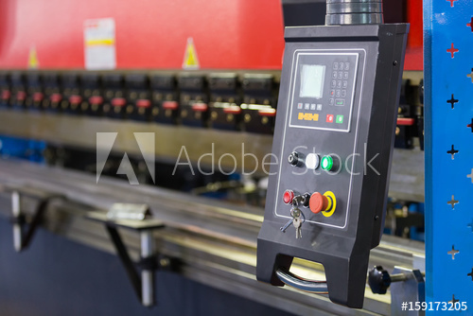 |  | 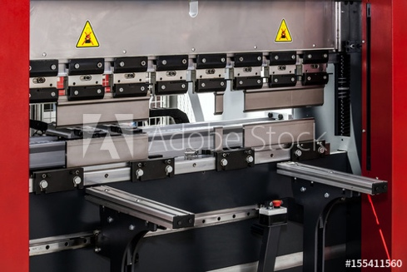
https://stock.adobe.com/images/highaccuracy-metal-sheet-bending-machine/159173205 | https://stock.adobe.com/images/worker-operator-bending-metal-sheet-process-by-sheet-bending-machine-for-bus-manufactuing-part-steel-folding-with-machine/191051985 | https://stock.adobe.com/images/sheet-metal-hydraulic-cnc-press-brake-machine-aluminum-folding-machine-with-automatic-controlling-bending/155411560
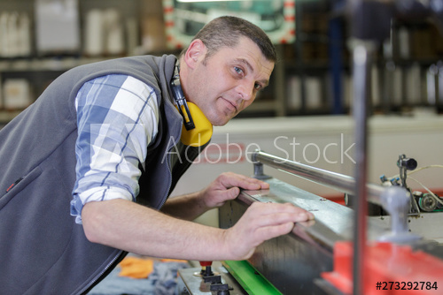 |  | 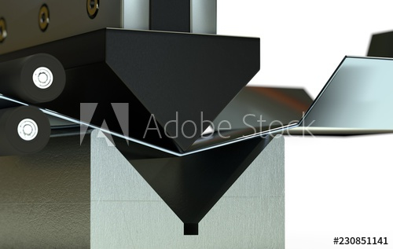
https://stock.adobe.com/images/industrial-factory-worker/172751767?asset_id=273292784 | https://stock.adobe.com/images/cnc-bending-machine/157103266 | https://stock.adobe.com/images/bended-metal-sheet-bending-machine-3d-render/230851141

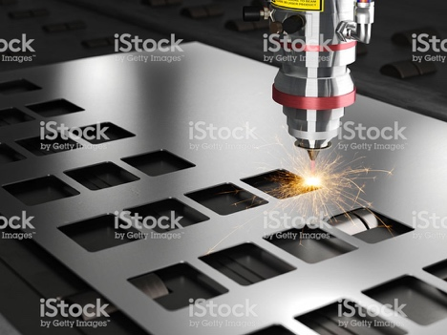 | 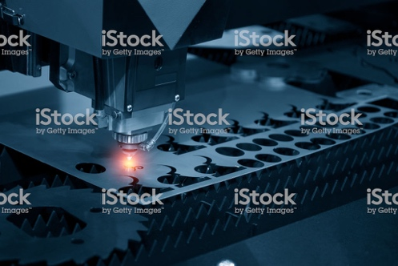 | 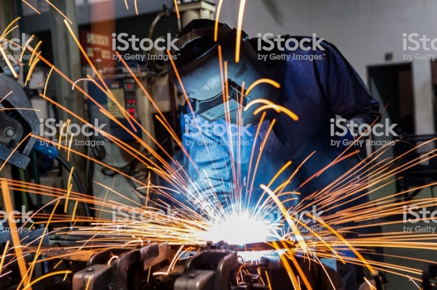
https://www.istockphoto.com/photo/laser-cutting-machine-gm629603990-112080249 | https://www.istockphoto.com/photo/the-cnc-laser-cut-machine-gm656304546-119460233 | https://www.istockphoto.com/photo/welder-is-welding-assembly-car-parts-in-factory-with-protection-mask-gm941595494-257355813
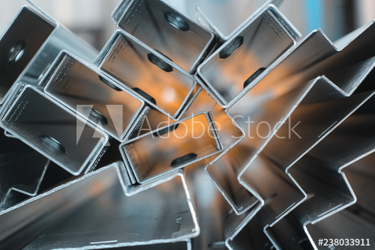 | 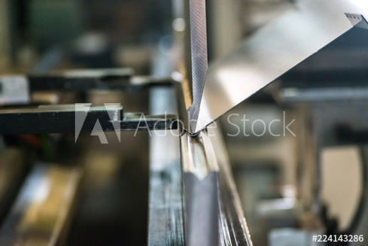 | 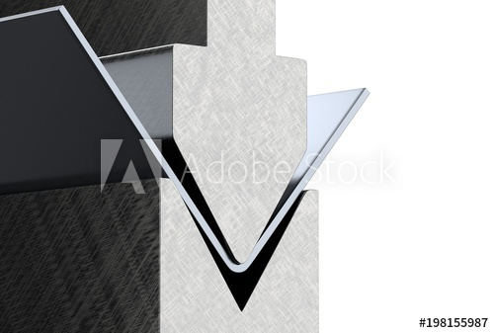
https://stock.adobe.com/images/focused-blurred-background-for-steel-sheet-metal-profiles-a-stell-zinc-coated-profiles-in-the-rack-in-artistic-blurry-organe-background-in-focus-version/238033911 | https://stock.adobe.com/images/sheet-metal-bending-process/224143286 | https://stock.adobe.com/images/bending-metal-sheet-by-sheet-bending-machine-3d-render/198155987
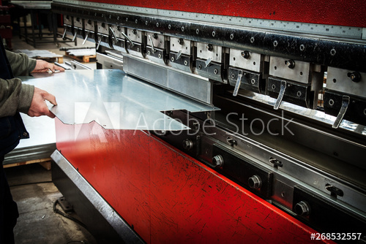 | 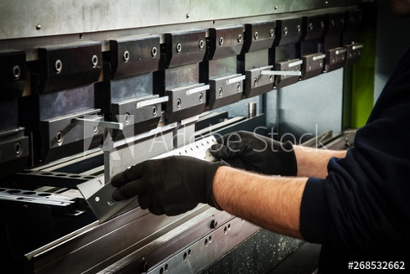 | 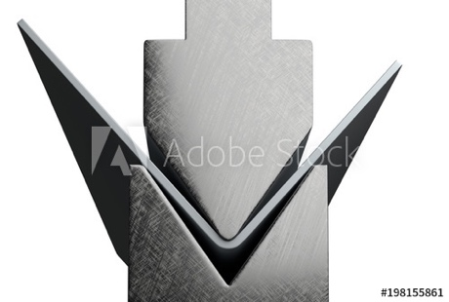
https://stock.adobe.com/images/cnc-bending-machine/268532557 | https://stock.adobe.com/images/cnc-bending-machine/268532557?asset_id=268532662 | https://stock.adobe.com/images/bending-metal-sheet-by-sheet-bending-machine-3d-render/198155861

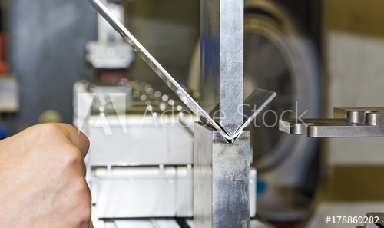 | 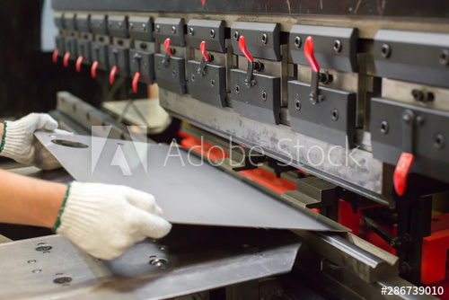 | 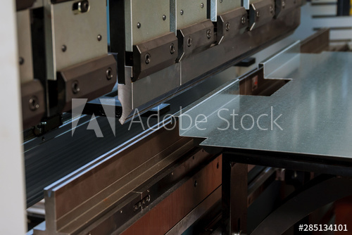
https://stock.adobe.com/images/bending-of-metal-on-the-machine/178869282 | https://stock.adobe.com/images/sheet-metal-bending-in-factory/286739010 | https://stock.adobe.com/images/bending-sheet-metal-with-a-hydraulic-machine-at-the-factory/285134101
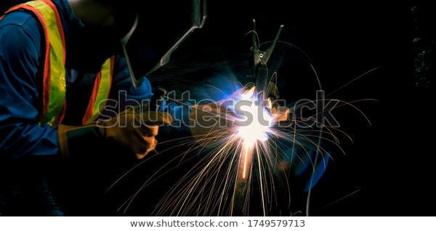 | 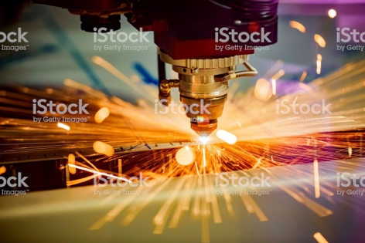 | 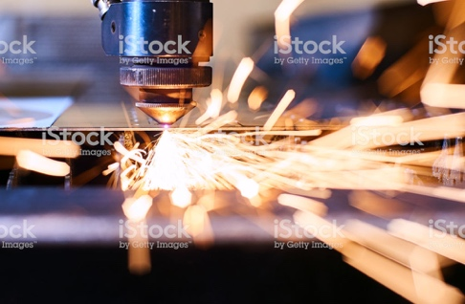
https://www.shutterstock.com/image-photo/industrial-technician-engineer-blue-protective-cloth-1749579713 | https://www.istockphoto.com/photo/cnc-laser-cutting-of-metal-modern-industrial-technology-gm1030477600-276089622 | https://www.istockphoto.com/photo/cnc-laser-cutting-of-metal-modern-industrial-technology-small-depth-of-field-gm1006017064-271553326
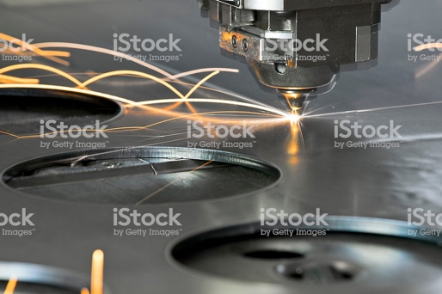 |  | 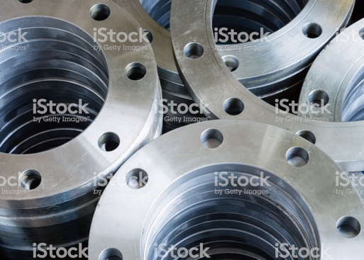
https://www.istockphoto.com/photo/laser-metal-cutting-manufacturing-tool-in-operation-gm154925535-15463791 | https://www.istockphoto.com/photo/detail-of-drilling-on-a-lathe-with-metal-shavings-gm1033330264-276727810 | https://www.istockphoto.com/photo/flanges-gm821368710-132817131

 |  | 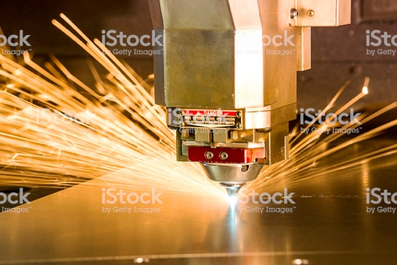
https://www.istockphoto.com/photo/cnc-lathe-processing-gm159758712-20426920 | https://www.istockphoto.com/photo/cnc-gas-cutting-metal-sheet-gm804317398-130425437 | https://www.istockphoto.com/photo/metal-laser-cutting-tool-gm169974538-24304597
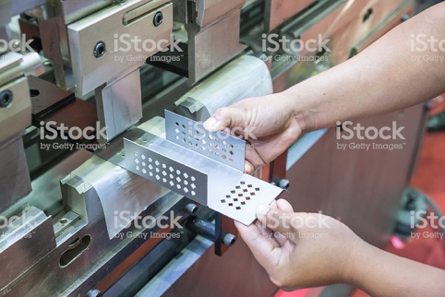 |  | 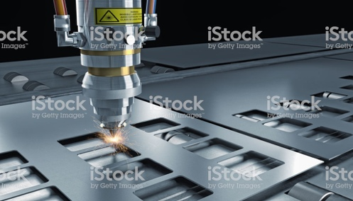
https://www.istockphoto.com/photo/worker-at-manufacture-workshop-operating-cidan-folding-machine-gm526322341-52669004 | https://www.istockphoto.com/photo/industrial-welding-automotive-in-thailand-gm636502566-112953179 | https://www.istockphoto.com/photo/laser-cut-machine-gm641339530-116161991
 | 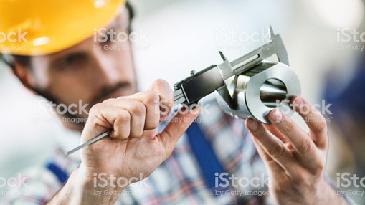 | 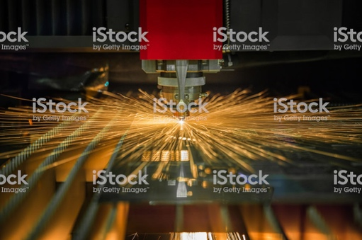
https://www.istockphoto.com/photo/milling-machine-gm174860738-23202203 | https://www.istockphoto.com/photo/product-inspection-gm682025038-125022445 | https://www.istockphoto.com/photo/cnc-laser-cuting-operate-cuting-steel-sheet-in-factory-gm943582202-257800746

 | 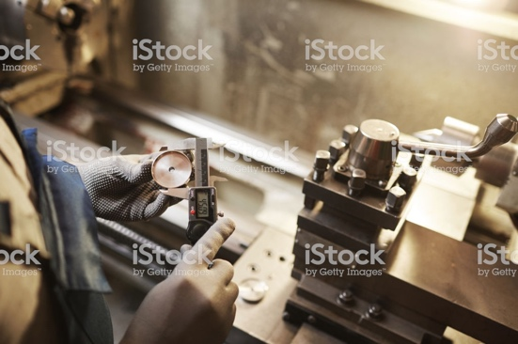 | 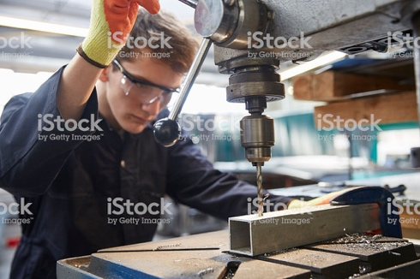
https://www.istockphoto.com/photo/employee-grinding-steel-with-sparks-gm497212064-78993229 | https://www.istockphoto.com/photo/worker-making-the-metal-details-gm1182626477-332155450 | https://www.istockphoto.com/photo/young-apprentice-using-pillar-drill-in-steel-fabrication-factory-gm519526968-90575445
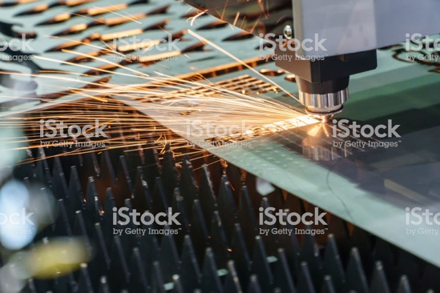 | 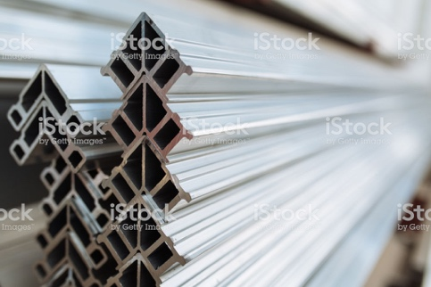 | 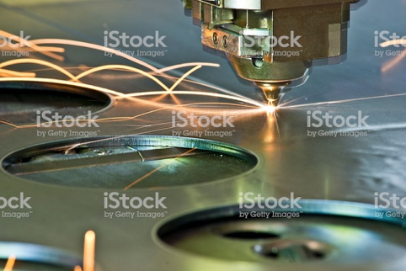
https://www.istockphoto.com/photo/the-fiber-laser-cutting-machine-gm884498736-245896376 | https://www.istockphoto.com/photo/stacking-corner-cleat-gm687971534-126493621 | https://www.istockphoto.com/photo/laser-plasma-cnc-metal-cutter-in-operation-gm519890007-49866468
https://stock.adobe.com/images/focused-blurred-background-for-steel-sheet-metal-profiles-a-stell-zinc-coated-profiles-in-the-rack-in-artistic-blurry-organe-background-in-focus-version/238033911 | https://stock.adobe.com/images/sheet-metal-bending-process/224143286 | https://stock.adobe.com/images/bending-metal-sheet-by-sheet-bending-machine-3d-render/198155987

Concept Photos:
https://www.shutterstock.com/image-photo/business-technology-internet-concept-businessman-pressing-271390541 | https://www.shutterstock.com/image-photo/hourglass-time-passing-concept-business-deadline-1308003958 | https://www.shutterstock.com/image-photo/time-action-clock-sign-131795831
https://www.shutterstock.com/image-photo/businessman-presses-compliance-icon-on-virtual-510191623 | https://www.shutterstock.com/image-photo/businessman-missing-deadline-deliverables-office-1511121581 | https://www.shutterstock.com/image-photo/businessman-writing-actions-not-words-on-230202661
https://www.shutterstock.com/image-photo/angry-caucasian-director-shirt-tie-helmet-1563799036 | https://www.shutterstock.com/image-photo/angry-businessman-having-phone-conversation-shouting-1727492740 | https://www.shutterstock.com/image-photo/angry-businessman-suit-protective-helmet-on-1512311621

https://www.istockphoto.com/photo/hands-of-man-people-fist-bump-team-teamwork-and-partnership-business-success-black-gm1133580260-300906432 | https://www.istockphoto.com/photo/group-of-business-people-holding-a-jigsaw-puzzle-pieces-gm840678292-136993333 | https://www.istockphoto.com/photo/checking-completed-tasks-on-a-list-gm1056305928-282284610
https://www.istockphoto.com/photo/win-win-strategy-gm480178678-68533211 | https://www.istockphoto.com/photo/gears-in-the-hands-of-people-against-the-sky-gm1152226597-312531165 | https://www.istockphoto.com/photo/problem-solution-business-gm698709788-129439059
Can’t make those parts

https://www.istockphoto.com/photo/engineering-gm171347670-20736619 | https://www.istockphoto.com/photo/3d-product-visualization-gm156351999-15793855 | https://www.istockphoto.com/photo/solution-concept-with-handshake-on-chalkboard-background-gm943960770-257879054

https://www.istockphoto.com/photo/young-happy-worker-and-manager-giving-each-other-manly-greet-at-steel-mill-gm1057484742-282602824 | https://www.istockphoto.com/photo/lie-gm172229879-381585 | https://www.istockphoto.com/photo/power-of-partnership-gm1028360792-275672331
https://www.istockphoto.com/photo/trust-gm939533958-256880216

They don’t wear hardhats.
PPE = Eyewear only. Welders wear sleeves.

